PROJECT DESIGN PHASE-1 SOLUTION ARCHITECTURE

TEAM ID: PNT2022TMID36188

|  |  |
| --- | --- |
| Date | 12 october 2022 |
| Team ID | PNT2022TMID36188 |
| Project Name | IOT based Smart Crop Protection For Agriculture |
| Maximum Marks | 2 Marks |

DESCRPITION:

* The device will detect the animals and birds using the Clarifai service.
* If any animal or bird is detected the image will be captured and stored in the IBM Cloud object storage.
* It also generates an alarm and avoid animals from destroying the crop.
* It also generates an alarm and avoid animals from destroying the crop.
* The image URL will be stored in the IBM Cloudant DB service.
* The device will also monitor the soil moisture levels, temperature, and humidity values and send them to the IBM IoT Platform.
* The image will be retrieved from Object storage and displayed in the web application.
* A web application is developed to visualize the soil moisture, temperature, and humidity values.
* Users can also control the motors through web applications

|  |
| --- |
| Buy DHT11- Digital Humidity and Temperature sensor Module Online in India |  Robocraze  **Temperature and Humidity**  **Sensor**  REES52 SOILSENSOR Soil Moisture Sensor and Automatic Watering System for  Arduino Te215 : Amazon.in: Industrial & Scientific  **Soil moisture**  Wi-Fi water Level / sump monitor Sensor with buzzer : Amazon.in: Home  Improvement  **Water level monitor** |

**Sensors**

**Data sent**

**Cell phone**

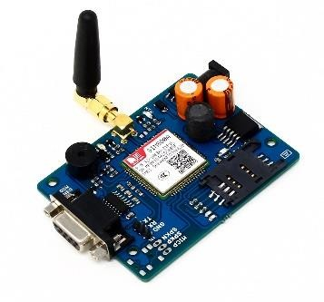

GSMGPRS module

**Power supply 5v**

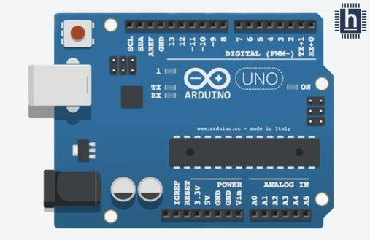

Centralized Arduino board

IOT cloud services



**Data transferred**

**Analog signals**

|  |
| --- |
| **Water pump**Pumps in Water Supply System - The Constructor  **Relay Driver** |

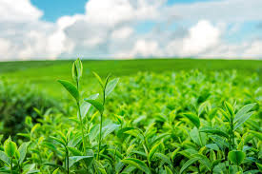

**IBM WATSON platform**

**Motor Controller**





Output



**Water flow**